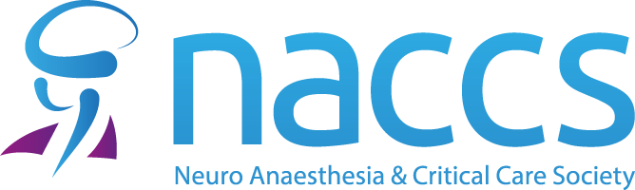

NACCS ASM Abstract Coordinator
Professor J P Coles
Box 93, Department of Anaesthesia
Cambridge University Hospitals NHS Foundation Trust
Cambridge Biomedical Campus
Hills Road
Cambridge
CB2 0QQ

Dear Professor Coles,

Abstract submission for NACCS ASM May 2nd - 3rd, 2024.

I would like to submit my/our abstract entitled [insert title here] for consideration for presentation orally or as a poster (delete if you do not wish your submission to be considered for one or the other).

I can confirm that ethical committee permission was obtained, or the study was registered with the hospital/governance department as an audit/service evaluation, or the patient has given written consent for the case report. I can confirm that approval permits for the work to be presented as part of the NACCS ASM program and published externally. I can provide written evidence concerning these details if requested to do so.

All the authors named on the abstract have seen and accept responsibility for the content, have disclosed any conflicts of interest, and accept the copyright transfer agreement the society makes on your behalf to secure publication of the successful abstracts in the Journal of Neurosurgical Anesthesiology.

The first author is a medically qualified trainee and will present the abstract (delete as necessary).

The first author is an allied health professional and will present the abstract (delete as necessary).

Yours sincerely

